Assignment 2:

1. Write a C Function that prints the cube of any number.
2. Write a C Function that takes one character and checks if it alphabet or not.
3. Write a C Function that check if the number if positive or negative.
4. Write a C Function that return the addition or subtraction or multiplication or division for two numbers. The function should take the required operation and two numbers as arguments. It also should check that the input operation is one of those operation that mentioned before and if not it should return error. The function should be implemented using switch case.
5. Write a C function to check if the input is an even number or an odd number, if even number return 0 if odd number return 1.

Example:

Input 7, Output = 1 (Odd)

Input 6, Output = 0 (Even)

1. Write C Function that converts the any letter from lowercase to uppercase.
2. Write a C Function that reads two integers and checks if the first is multiple of the second.
3. Write a C Function that display Prime Numbers between Intervals (two numbers) by Making Function.
4. Write a C Function that swaps the value of two integer numbers.
5. You are designing a poster which prints out numbers with a unique style applied to each of them. The styling is based on the number of closed paths or holes present in a giver number. The number of holes that each of the digits from 0 to 9 have are equal to the number of closed paths in the digit. Their values are:
   * 1, 2, 3, 5 and 7 = 0 holes.
   * 0, 4, 6, and 9 = 1 hole.
   * 8 = 2 holes.

Given a number, you must determine the sum of the number of holes for all of its digits. For example, the number 819 has 3 holes.

**Function Description**

Complete the function countHoles. The function must return an integer denoting the total number of holes in num.

1. Write a C function that returns 1 if the input number is a power of 2 and return 0 if the input number is power of 2.

For example: 0, 2 and 16 are power of 2.

1, 10 and 30 are not power of 2.

1. Write a C function that calculates the required heater activation time according to the input temperature of water.

* if input temperature is from 0 to 30, then required heating time = 7 mins.
* if input temperature is from 30 to 60, then required heating time = 5 mins.
* if input temperature is from 60 to 90, then required heating time = 3 mins.
* if input temperature is more than 90, then required heating time = 1 mins.
* if temperature is invalid (more than 100), return 0 Example:

Input = 10 → output = 7 Input = 35 → output = 5

1. In this challenge write a function to add two floating numbers. Determine the integer floor of the sum. The floor is the truncated float value, anything after the decimal point is dropped. For instance floor(1.1+3.05)=floor(4.15)=4
2. Write a C Function that calculate the Fibonacci series using recursive method.

The Fibonacci Series : 0,1,1,2,3,5,8,13,21,…

1. Write a C function to reverse the binary of an 8-bits number. For example if the input number is 10001101 the output number should be 10110001.
2. Write a C function to count the number of 1’s in an unsigned 32-bit integer.
3. Write a C function to count the number of 1’s in an unsigned 8-bit integer.
4. Given two integers: L and R, Find the maximal value of A xor B where A and B satisfy the condition L =< A <= B <= R Constrains: 1 <= L <= R <= 1000

**Input format:** the input contains two lines first line contains L and next line contains R.

**Output format:** The maximum value of A xor B

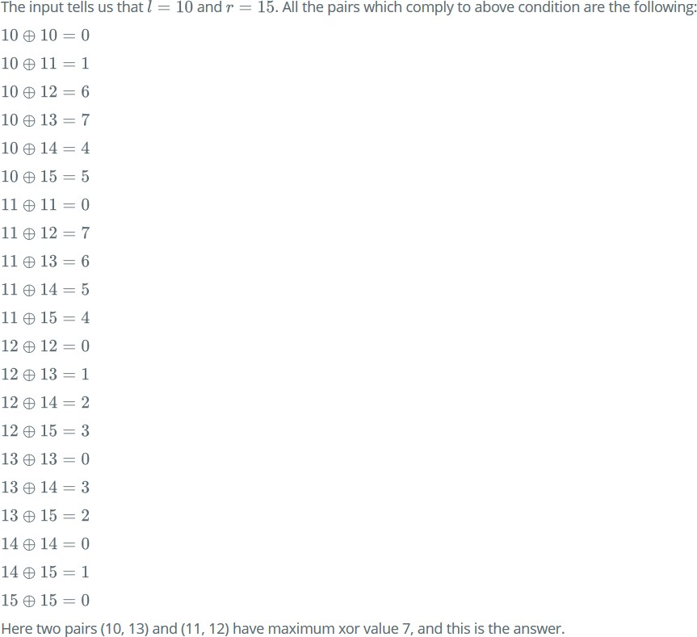

1. Given a positive integer z, check if z can be written as 𝑝𝑞, where p and q are positive integers than 1, if z can be written as 𝑝𝑞 return 1 else return 0.

Description:

A positive integer that needs to be determined if it can be expressed as a power of square number.

1. Write a C function that return 0 if a given number is a power of 3, otherwise return 1.